Childhood Asthma Control Test for children 4 to 11 years old
Know the score

This test will provide a score that may help your doctor determine if your child’s asthma treatment plan is working or if it might be time for a change.
How to take the Childhood Asthma Control Test
Step 1: Let your child respond to the first four questions (1 to 4). If your child needs help reading or understanding the question, you may help, but let your child select the response. Complete the remaining three questions (5 to 7) on your own and without letting your child’s response influence your answers. There are no right or wrong answers.
Step 2: Please Circle the response to each question.
Step 3: Return the completed test to the surgery.
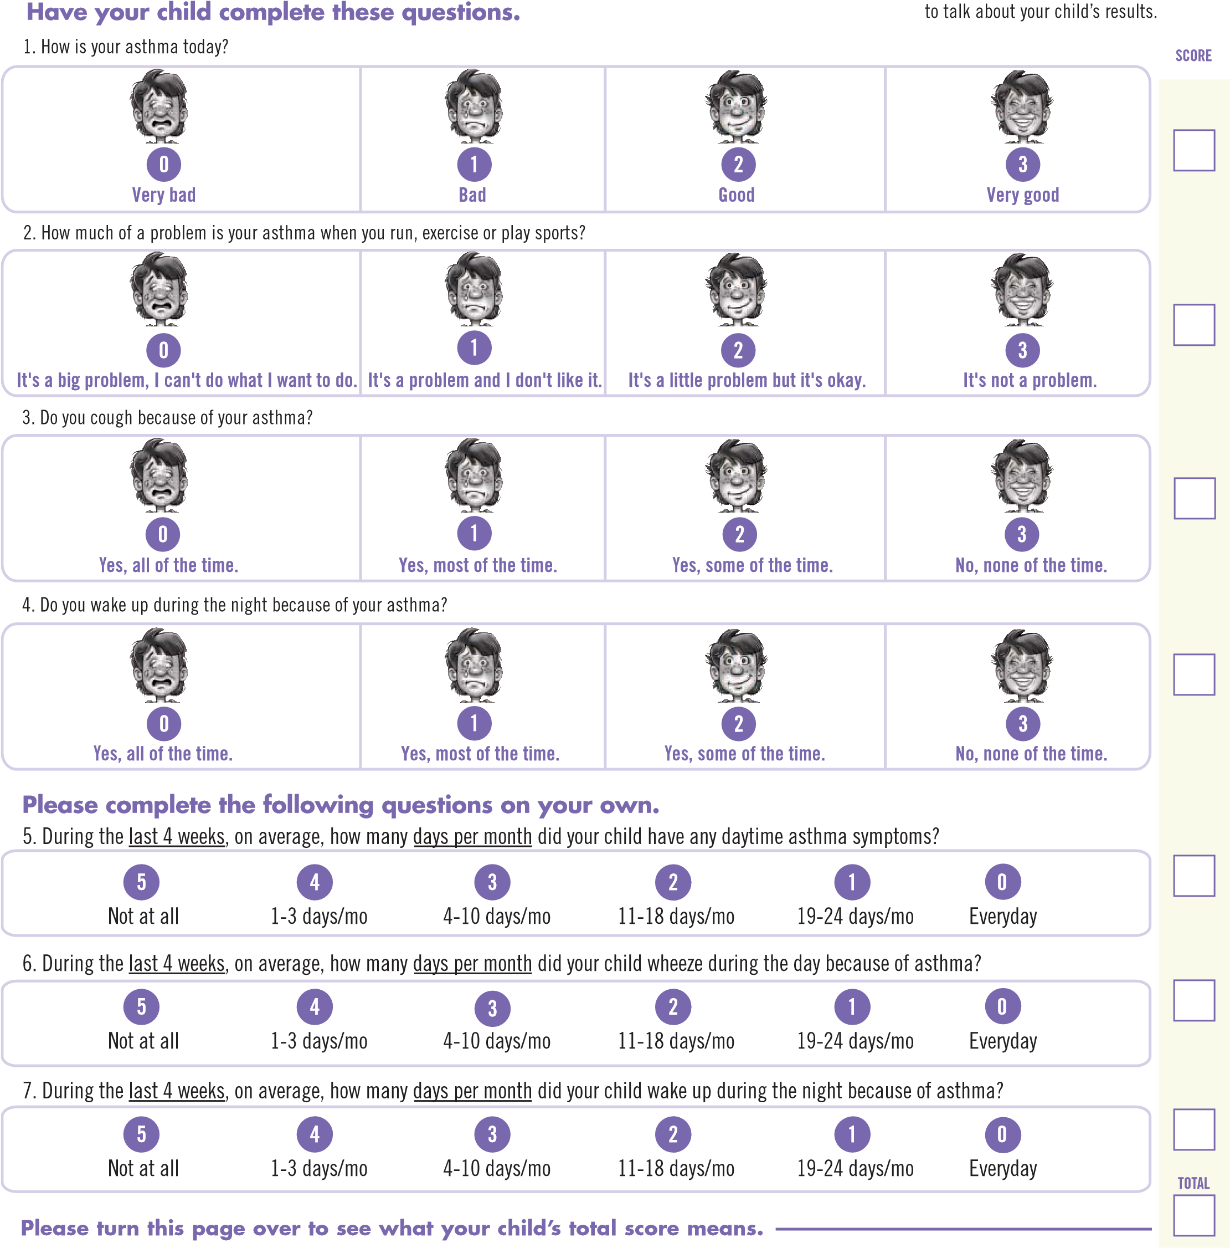

Please answer the following additional questions:

- Do you want your child to have a flu vaccination this year? YES NO

- How many exacerbations has your child had in the last 12 months

- Do you have a Peak Flow Meter? YES NO

- Please provide the following so that we can contact you to book an appointment

Email address

Phone Number

What does it mean if my child scores 19 or less?
- If your child’s score is 19 or less, it may be a sign that your child’s asthma is not under control
- An appointment will be made for you to discuss your child’s asthma score with their doctor/nurse. At this appointment you will be able to discuss whether you should change your child’s asthma treatment plan
- You can also ask the doctor/nurse about daily long-term medications that can help control airway inflammation and constriction, the two main causes of asthma symptoms. Many children may need to treat both of these on a daily basis for the best asthma control

